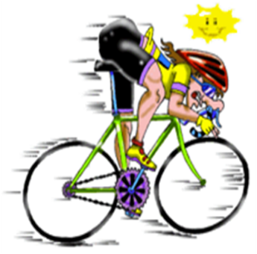 | ROTARY CLUB OF BANFF  Supported by  Banff Round Table  and  Banff Inner Wheel

SUNDAY 28th May 2023

10am START at the Deveron Community and Sports Centre, Whinhill Road car park
PLEASE PRINT CLEARLY

Full Name | ……………………………………………………………………………………………………………………………………………
Address | ……………………………………………………………………………………………………………………………………………
Tel No. | ……………………………… | Mobile No. | …………………………………………
E-mail | ………………………………………………………………………………………..
Date of Birth | …………………………….. | Sex (circle) | Male | Female

□ | 25 mile cycle | □ | 8 mile cycle 4 mile cycle

Parental Consent  (Under 12s)  Children under 8 must be accompanied by an adult | Name  …………… |  | Address  ……………………………….. |  | Signature  ………………………
DISCLAIMER
I understand that I enter the Banffshire Cycle Challenge at my own risk and that no person(s) or organisation(s) will be held responsible for any injury, accident or loss to myself, prior to, during or after the event. I understand the organizers reserve the right to alter the arrangements and conditions should circumstances require. I am in good health and confirm this challenge is within my capabilities.

Signature | ……………………………………………………………………... | Date…………………………….
Print Name | …………………………………………………………………….

